UPES PYTHON LAB ASSIGNMENT

***EXPERIMENT – 12&13***

Q1.

1. import Tkinter package and create a window and set its title
2. set the default window size using geometry function
3. Create a label with “Hello” text in it and set its position on the form.
4. Adda button to the window with “CLICK ME” written on it.
5. change the foreground and background color for the button created above
6. Create a function that will be executed when the button is clicked and print “Button was clicked” on clicking the button

SOL:-

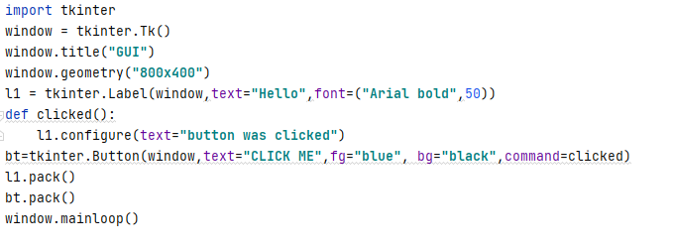

***OUTPUT :***

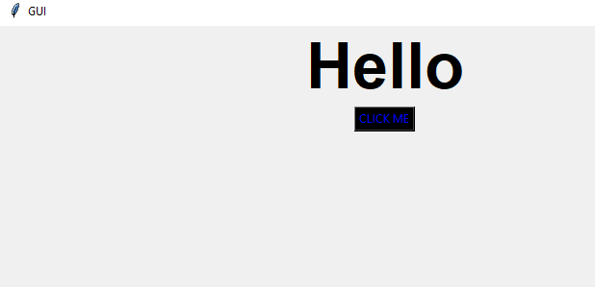

***OUTPUT AFTER CLICKING BUTTON***

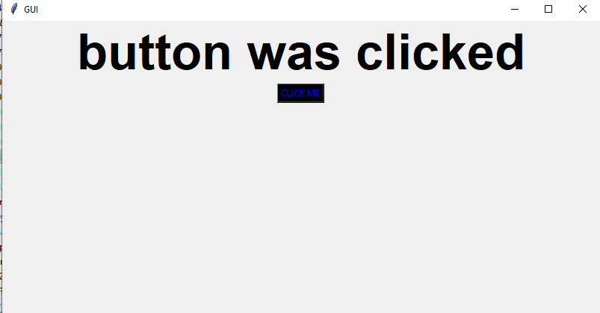

Q2 This. is the continuation of Question1, add the given below features in the above program:

1. Take**user name** as input using the Tkinter Entry class
2. Print the entered text (username) on clicking the button.
3. Create three RadioButtons as displayed below



1. Print the currently selected radio button or the radio button value.

**SOL:-**

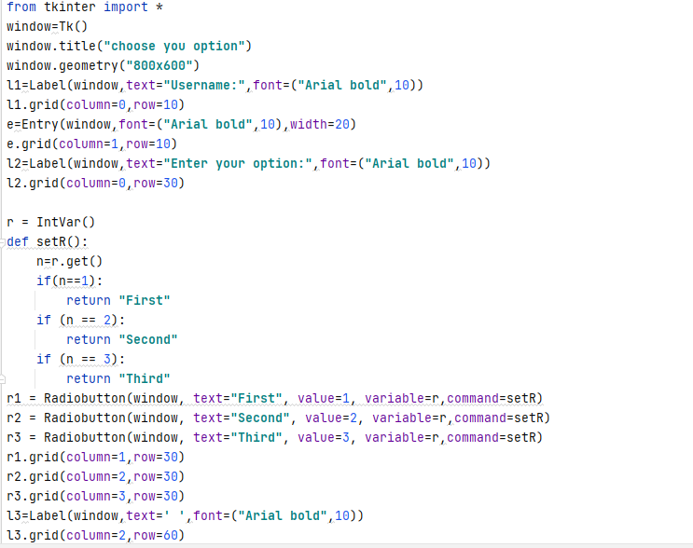

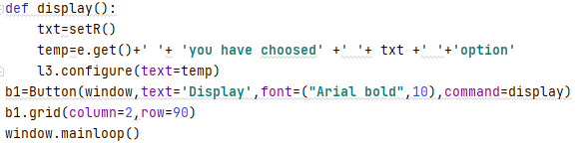

OUTPUT:-

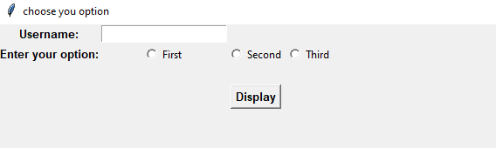

**Output after enter details:**

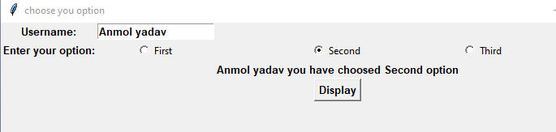

Q3. Write a program to accept following details from a student using GUI

1. Name of the student (using Textbox)

2. Gender (Using radio button)

3. Qualification (Using List)

4. Marks of three subjects (using Textbox)

Compute the percentage of the student and display it in a textbox.

**Sol:-**

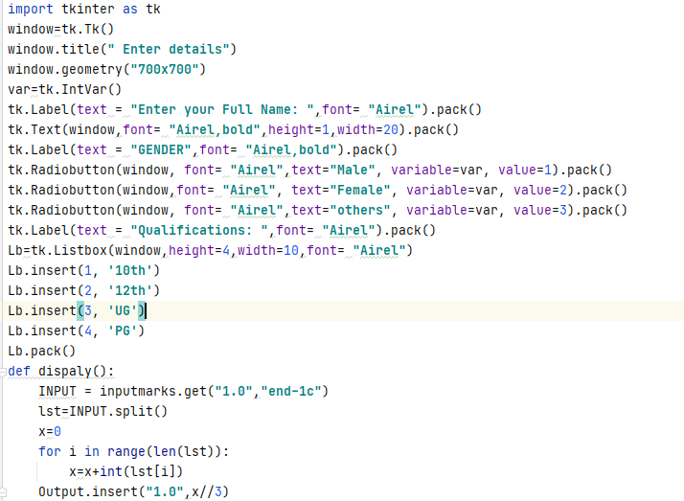

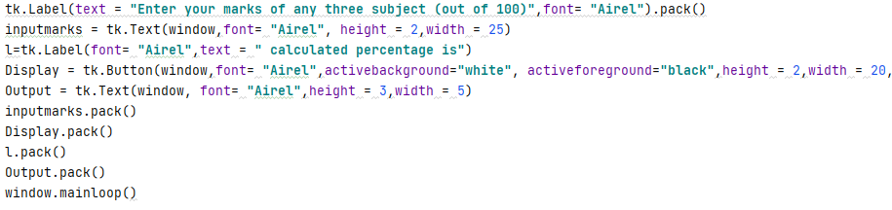

**Output:-**

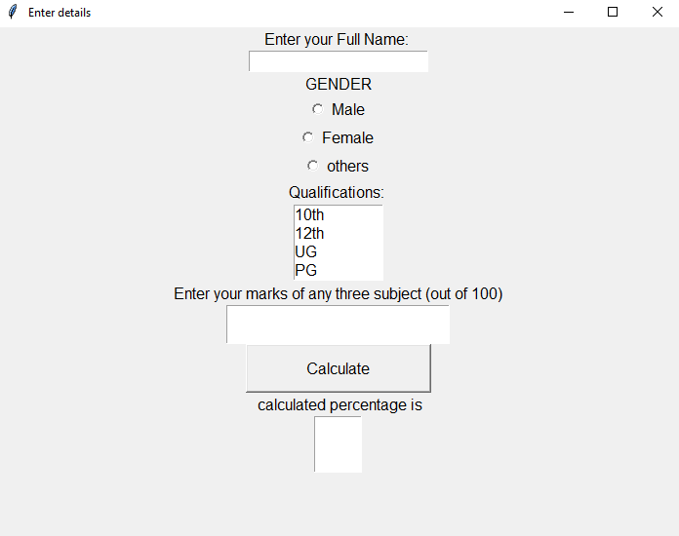

**Output after enter the user details:-**

